

**NATIONAL UNIVERSITY SCIENCE AND TECHNOLOGY (NUST)**

(**High Impact Skills Development Program for Gilgit Baltistan**)

**Project Title:** Online Retail Segmentation by using SQL queries.

A Project Report

**Email Address:** rabiajan980@gmail.com

**GitHub:** https://github.com/janrabia-980/DSAI

Project Overview

Customer segmentation on given table ‘online retail’ has been implemented by using My SQL queries. Customer segmentation includes typical strategy adopted by organizations to categories clients based on their performance, demographics, shopping patterns, or other churn analysis.

Customer segmentation constitutes a widely adopted strategic approach within organizations, aimed at systematically categorizing clients by analyzing a spectrum of factors such as demographics, shopping patterns, and other discernible traits. By effectively segmenting the customer base, businesses gain the ability to tailor their offerings, communications, and marketing efforts with a higher degree of precision, ultimately leading to enhanced customer satisfaction, targeted engagement, and improved overall business performance.

**DATA DETAILS (METADATA)**

Look for a dataset that contains information about customers such as demographic information, purchasing history, and customer interactions. The data set contains the following features and attributes:

**Invoice No:** The invoice number for each transaction

**Stock Code:** The unique code for each product sold

**Description:** The description of each product sold

**Quantity:** The quantity of each product sold in each transaction

**Invoice Date**: The date and time of each transaction

**Unit Price:** The price of each product sold

**Customer ID:** The unique identifier for each customer

**Country:** The country where each transaction occurred

**SQL Project Idea**: Use SQL queries to answer the following questions

1. **MY SQL Queries:**

The two types of queries basic and advance given below:

* 1. **Basic Queries**

Following five basic SQL queries required to be executed on ‘online_retail’ table:

**1.1.1 Beginner Query-1 Meta Data**

Some features in the given table ‘online retail’ data can be display with more details and description that is Metadata, as given below:

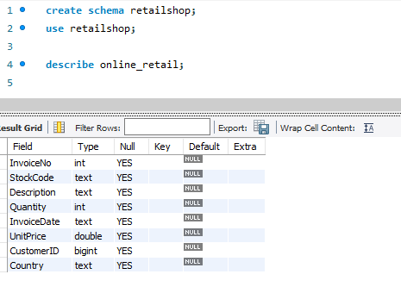

**1.1.2 Beginner Query-2 Distribution of Order Values Across all Customers**

**For distribution first calculate the order value**

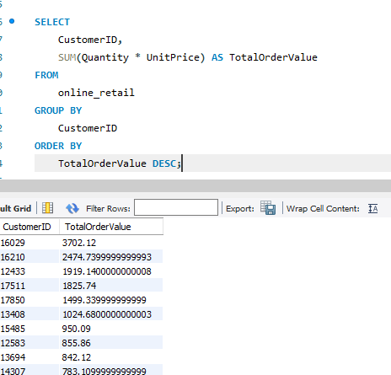

**And then distribute the order value across all the customers**

**1.1.3 Query-3 Customers Purchased Unique Products**

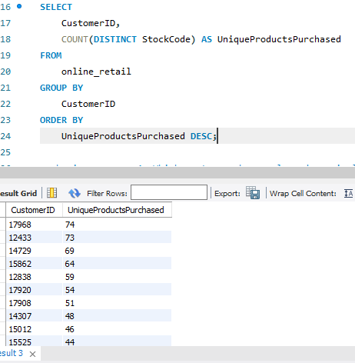

**1.1.4 The Customers having Single Purchase.**

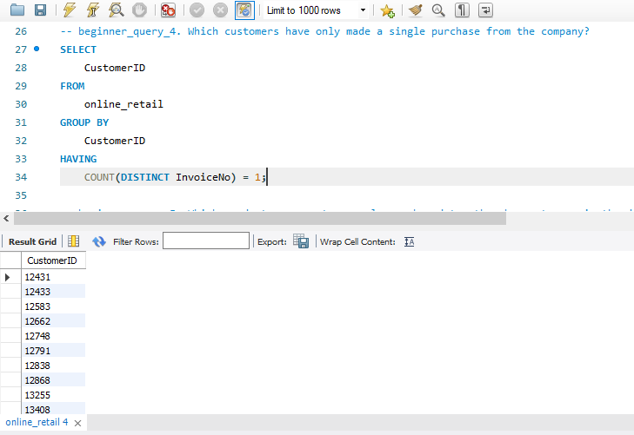

**1.1.5 Products Most Commonly Purchased together by Customers.**

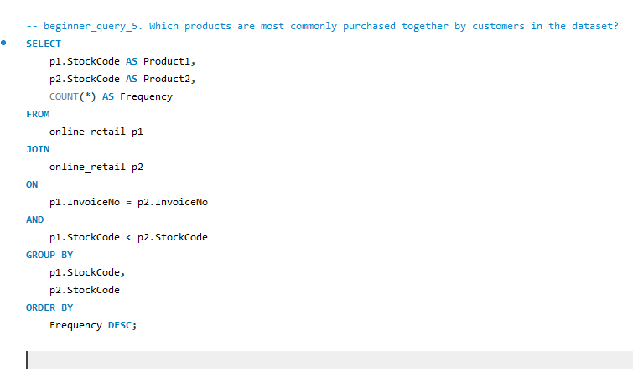

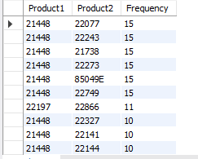

* 1. **Advanced SQL Queries**

Following five basic SQL queries required to be executed on above “online_retail” table:

* + 1. **Customer Segmentation by Purchase Frequency**

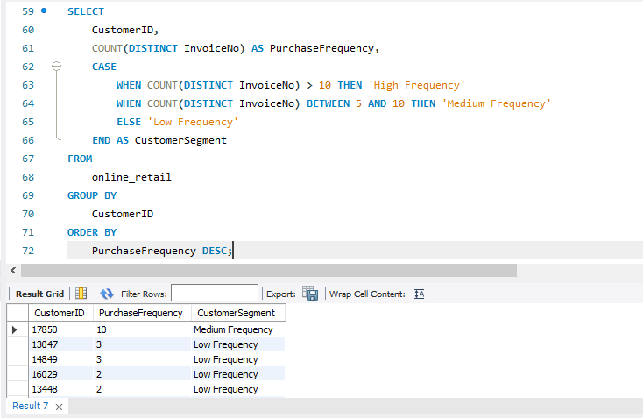

* + 1. **Average Order Value by Country**

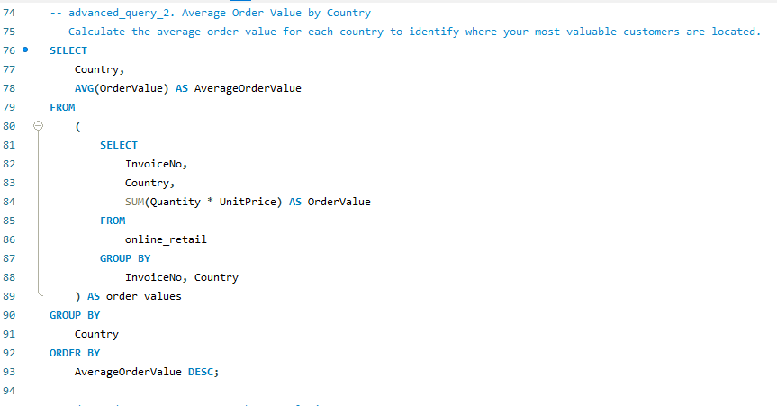

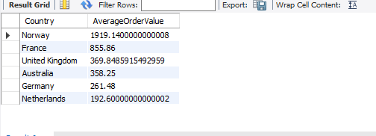

* + 1. **Customer Churn Analysis**

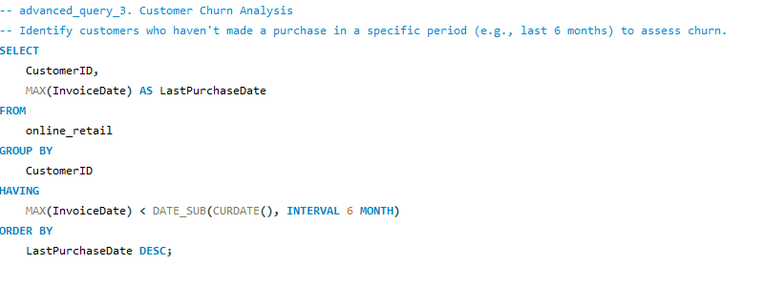

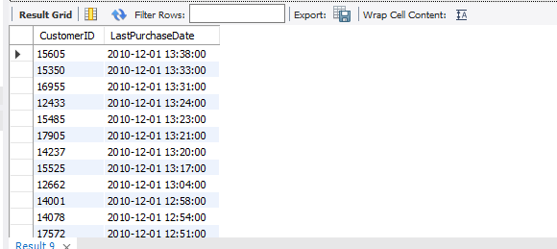

* + 1. **Product Affinity Analysis**

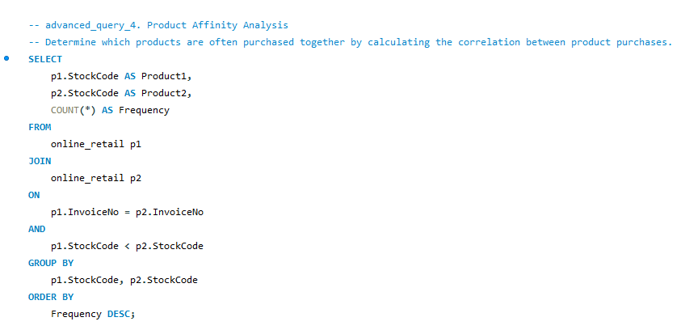

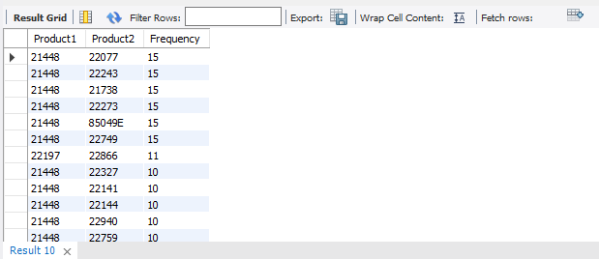

* + 1. **Time-based Analysis**

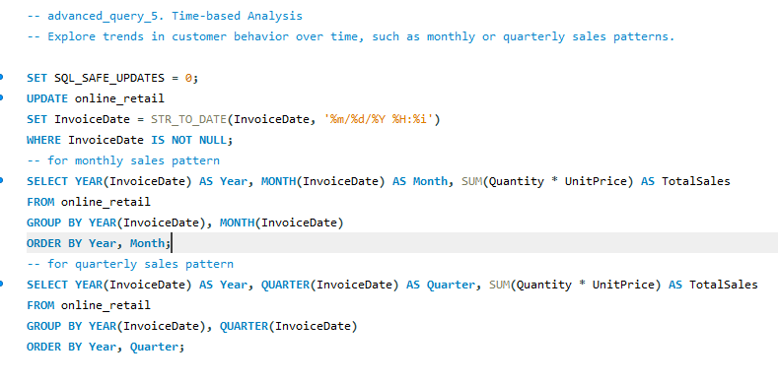

* + - 1. **Monthly Sales**

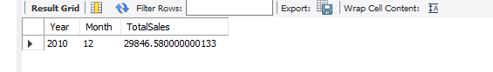

**1.2.5.2 Quarterly Sales**

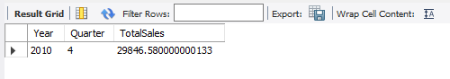

**The End**